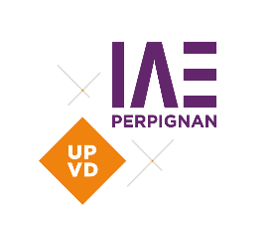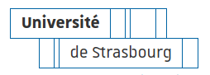



Chaire Vin et Tourisme

**WORKSHOP REGISTRATION FORM**

**4th International Research Workshop on**

**Wine Tourism and Agrifood: Resilience and Transitions**

15-17th October 2025 Perpignan, France

**PERSONAL INFORMATION**

**Full Name:**

**Email Address:**

**Phone Number:**

**Mailing Address (if needed):**

**ACADEMIC / PROFESSIONAL AFFILIATION**

**Institution / Organization:**

**Position / Title:**

**Field of Expertise / Discipline:**

**SCIENTIFIC PARTICIPATION**

**Are you submitting a paper or an abstract?** Yes   No

If yes, please provide the following:

* **Title of the presentation:**
* **Keywords (3–5):**
* **Authors and co-authors:**
* **Technical requirements for presentation (e.g., projector, sound, etc.):**

**LOGISTICS AND SPECIAL REQUIEREMENTS**

**Will you participate in the organized meals (welcome drink, lunches, dinner)?**  
 Yes  No  Partially (please specify: )

**Dietary requirements:**  
 Vegetarian  Vegan  Gluten-free  Allergies (please specify: )  
 None

**Accessibility or special needs:**  
 Yes (please specify: )  No

**REGISTRATION FEES**

**Registration category:**  
 PhD Student: 180 €  
 Academic / Researcher: 250 €  
 Professional: 250 €  
 Spouse / Accompanying person: 140 €

**Payment method:**  
The payment must be made by bank transfer.

Payment reference: “WTAF octobre 2025 IAE-MRM”



Do you need a proof of payment?  Yes  No

**To complete your registration, please send the completed form to the following address:** [**jodie.esteve@univ-perp.fr**](mailto:jodie.esteve@univ-perp.fr)

For further information please contact: [wtaf2025workshop@univ-perp.fr](mailto:wtaf2025workshop@univ-perp.fr)

With the support of



